**Practical No-10**

**Write a program to implement Aggregation and Indexing in MongoDB.**

use College

--------------------------------------

show dbs

--------------------------------------

db.createCollection("Student")

--------------------------------------

db.Student.insert({Roll_no:1,Name:"Premraj",Gender:"Male",Age:20,Marks:89})

db.Student.insert({Roll_no:2,Name:"Nikita",Gender:"Female",Age:19,Marks:80})

db.Student.insert({Roll_no:3,Name:"Manasi",Gender:"Female",Age:19,Marks:56})

db.Student.insert({Roll_no:4,Name:"Rohan",Gender:"Male",Age:19,Marks:78})

db.Student.insert({Roll_no:5,Name:"Mahesh",Gender:"Male",Age:20,Marks:66})

db.Student.insert({Roll_no:7,Name:"Supriya",Gender:"Female",Age:21,Marks:39})

db.Student.save({Roll_no:6,Name:"Prajakta",Gender:"Female",Age:19,Marks:85})

--------------------------------------

db.Student.find()

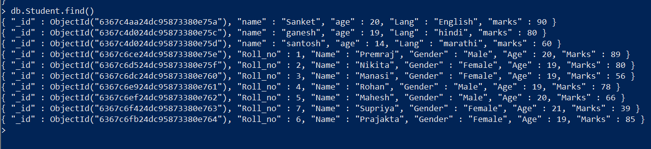

--------------------------------------

db.Student.createIndex({Roll_no:1})

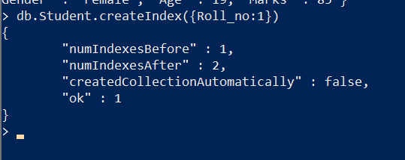

--------------------------------------

db.Student.getIndexes()

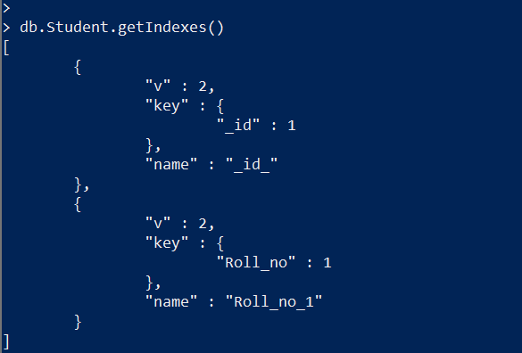

--------------------------------------

**insert records:-**

db.Student.update({Name:"Premraj"},{$set:{Subject:"TOC"}},{multi:true})

db.Student.update({Name:"Nikita"},{$set:{Subject:"DBMS"}},{multi:true})

db.Student.update({Name:"Manasi"},{$set:{Subject:"TOC"}},{multi:true})

db.Student.update({Name:"Prajakta"},{$set:{Subject:"SEPM"}},{multi:true})

db.Student.update({Name:"Supriya"},{$set:{Subject:"CN"}},{multi:true})

db.Student.update({Name:"Mahesh"},{$set:{Subject:"SEPM"}},{multi:true})

db.Student.update({Name:"Rohan"},{$set:{Subject:"DBMS"}},{multi:true})

--------------------------------------

db.Student.find()

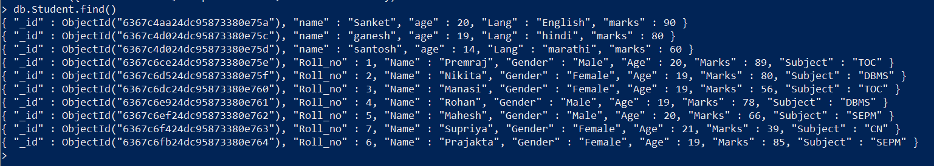

--------------------------------------

**min marks of records:-**

db.Student.aggregate([

{$group:{_id:"$Subject",Marks:{$min:"$Marks"}}

}])

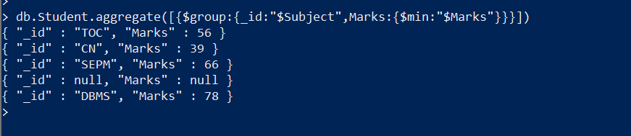

--------------------------------------

**max marks of records:-**

db.Student.aggregate([{$group:{_id:"$Subject",Marks:{$max:"$Marks"}}}])

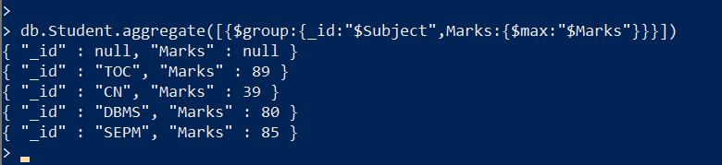

--------------------------------------

**sum of marks of records:-**

db.Student.aggregate([{$group:{_id:"$Subject",Marks:{$sum:"$Marks"}}}])

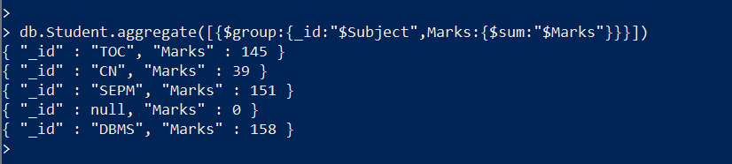

--------------------------------------

**avg marks of records:-**

db.Student.aggregate([{$group:{_id:"$Subject",Marks:{$avg:"$Marks"}}}])

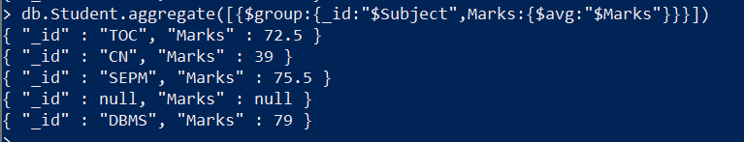

--------------------------------------

**first marks of records:-**

db.Student.aggregate([{$group:{_id:"$Subject",Marks:{$first:"$Marks"}}}])

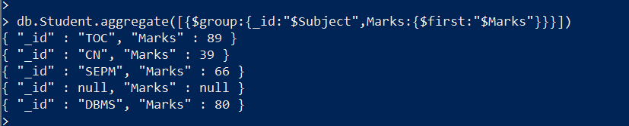

--------------------------------------

**last marks of records:-**

db.Student.aggregate([{$group:{_id:"$Subject",Marks:{$last:"$Marks"}}}])

